HW4 문제 정리

A method that gets a value from a class's field but does not change it is known as a mutator method.

* 1. True
  2. **False양식의 맨 아래양식의 맨 위**

The term "no-arg constructor" is applied to any constructor that does not accept arguments.

1. True
2. **False**

When a local variable in an instance method has the same name as an instance field, the instance field hides the local variable.

1. **True**
2. False

The term "default constructor" is applied to the first constructor written by the author of the class.

1. True
2. **False**

A method that stores a value in a class's field or in some other way changes the value of a field is known as a mutator method.

1. **True**
2. False

The java.lang package is automatically imported into all Java programs.

1. **True**
2. False

Shadowing is the term used to describe where the field name is hidden by the name of a local or parameter variable.

1. **True**
2. False

A class is not an object. It is a description of an object.

1. **True**
2. False

Instance methods should be declared static.

1. True
2. **False (should never be declared static)**

When an object is passed as an argument to a method, the object's address is passed into the method's parameter variable.

1. **True**
2. False

A class's responsibilities include ________.

1. the things a class is responsible for knowing
2. the things a class is responsible for doing
3. **both of these**
4. neither of these

Data hiding (which means that critical data stored inside the object is protected from code outside the object) is accomplished in Java by ________.

1. **using the public access specifier on the class methods**
2. using the private access specifier on the class methods
3. using the private access specifier on the class fields
4. using the private access specifier on the class definition

A group of related classes is called a(n) ________.

1. archive

**2. package**

3. collection

4. attachment

Class objects normally have ________ that perform useful operations on their data, but primitive variables do not.

1. fields

2. relationships

3. **methods**

4. instances

You should not define a class that is dependent on the values of other class fields ________.

1. in order to keep it current

2. because it is redundant

**3. in order to avoid having stale data**

4. because it should be defined in another class

What does the following UML diagram entry mean?

+ setHeight(h : double) : void

**1. a public method with a parameter of data type double that does not return a value**

2. a private field called setHeight that is a double data type

3. a private method with no parameters that returns a double data type

4. a public field called setHeight that is a double data type

A constructor is a method that ________.

1. returns an object of the class

2. never receives any arguments

**3. performs initialization or setup operations**

4. removes the object from memory

It is common practice in object-oriented programming to make all of a class's ________.

**1. fields private**

2. methods private

3. fields public

4. fields and methods public

A class specifies the ________ and ________ that a particular type of object has.

1. relationships, methods

2. fields, object names

**3. fields, methods**

4. relationships, object names

________ refers to combining data and code into a single object.

1. Data hiding

2. Abstraction

3. The constructor

**4. Encapsulation**

For the following code, which statement is **not** true?

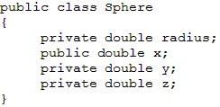

**1. The z field is available to code written outside the Sphere class.**

2. The radius field is not available to code written outside the Sphere class.

3. The radius, x, y, and z fields are members of the Sphere class.

4. The x field is available to code that is written outside the Sphere class.

For the following code, which statement is **not** true?

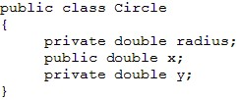

**1. The y field is available to code written outside the Circle class.**

2. The radius field is not available to code written outside the Circle class.

3. The radius, x, and y fields are members of the Circle class.

4. The x field is available to code that is written outside the Circle class.

A constructor ________.

1. always accepts two arguments

**2. has the same name as the class**

3. has the return type of void

4. always has a private access specifier

The scope of a private instance field is ________.

**1. the instance methods of the same class**

2. inside the class but not inside any method in that class

3. inside the parentheses of a method header

4. the method in which it is defined

Two or more methods in a class may have the same name as long as ________.

1. they have different return types

**2. they have different parameter lists**

3. they have different return types but the same parameter list

4. You cannot have two methods with the same name.

The scope of a public instance field is ________.

1. only the class in which it is defined

2. inside the class but not inside any method

3. inside the parentheses of a method header

**4. the instance methods and methods outside the class**

Overloading means that multiple methods in the same class ________.

1. have the same name but different return types

2. have different names but the same parameter list

**3. have the same name but different parameter lists**

4. perform the same function

When an object is passed as an argument to a method, what is passed into the method's parameter variable?

1. the class name

**2. the object's memory address**

3. the values for each field

4. the method names

A constructor ________.

1. always accepts two arguments

2. has the return type of void

**3. has the same name as the class**

4. always has a private access specifier

A(n) ________ can be thought of as a blueprint that can be used to create a type of ________.

1. object, class

**2. class, object**

3. cookie, cake

4. object, method

A reference variable stores a(n) ________.

1. binary encoded decimal

**2. memory address**

3. object

4. string

A UML diagram does not contain ________.

1. the class name

2. the method names

3. the field names

4. the object names

Java allows you to create objects of the ________ class in the same way you would create primitive variables.

1. Random

**2. String**

3. PrintWriter

4. Scanner

Which of the following statements will create a reference, str, to the String "Hello, World"?

**1. String str = "Hello, World";**

2. string str = "Hello, World";

3. String str = new "Hello, World";

4. str = "Hello, World";

e

Instance methods do not have the ________ keyword in their headers.

1. public

**2. static**

3. private

4. protected

설명 : static 은 모두가 접근할 수 있는 공유자원이기 때문에 static에는 this라는 내것이라는 개념이 존재하지 않는다.

The ________ package is automatically imported into all Java programs.

1. java.java

2. java.default

3. java.util

**4. java.lang**

Given the following code, what will be the value of finalAmount when it is displayed?

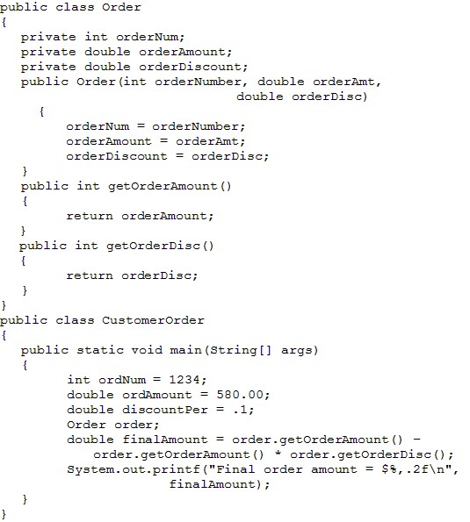

1. 528.00

2. 580.00

3. There is no value because the constructor has an error.

**4. There is no value because the object, order, has not been created.**

Analyze the following code:

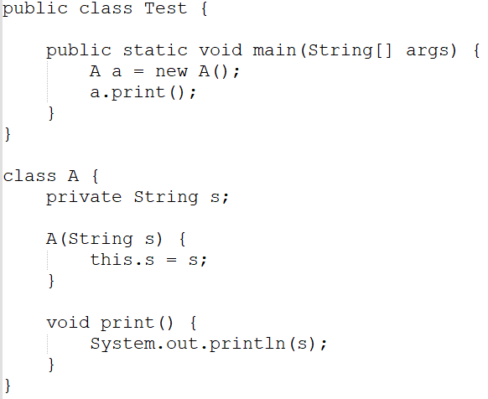

1. The program has a compile error because class A is not a public class.

2. The program has a compile error because class A does not have a default constructor.

3. The program compiles and runs fine and prints nothing.

**4. The program would compile and run if you change A a = new A() to A a = new A("5").**

Given the following code, what will be the value of finalAmount when it is displayed?

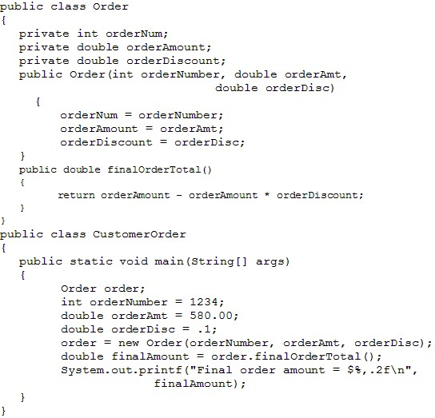

1. 528.00

2. 580.00

**3. 522.00**

4. There is no value because the object, order, has not been created.

Select all that apply. Which of the following are classes from the Java API?

**1. Scanner**

**2. Random**

3. Package

**4. PrintWriter**